Institutional affiliation
Students name
Task
Date

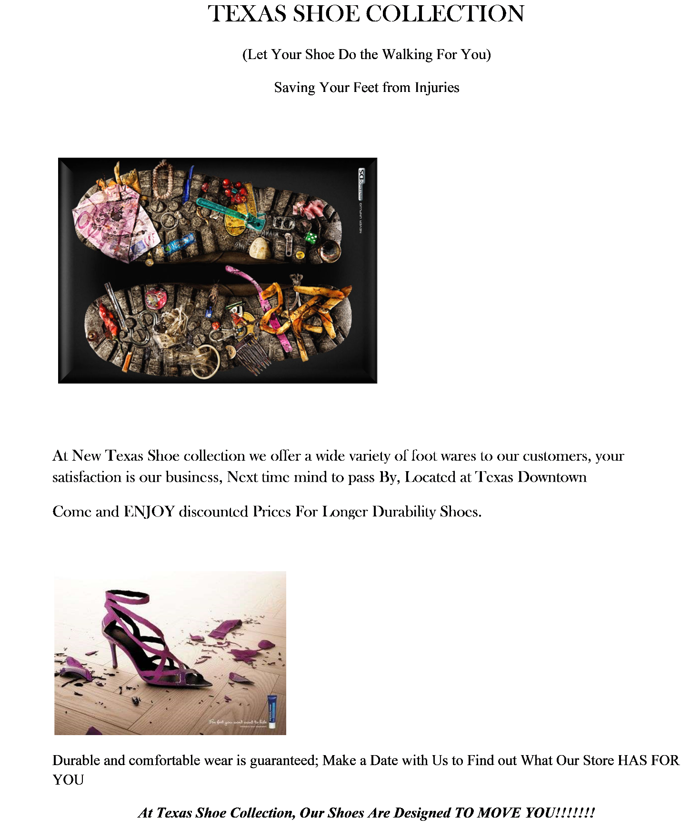

REFERENCES
Halted, S. (2019. How to Convert Word Documents into Images. Retrieved from
https://turbofuture.com/computers/How-to-Convert-Word-Document-into-Image-jpeg-png-gif-tiff

